25th Anniversary
9/11 Remembrance Ceremony
Sponsored by Hudson American Legion Post #184
Friday, September 11th at 6:30 p.m.
M.C. Smith Elementary School
102 Harry Howard Ave.
Hudson, NY 12534
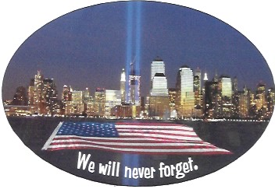
Guest Speaker, Angel Rubet, survivor of the attack on Twin Towers
The public is invited to attend
Our goals for this event are to honor the first responders in our community, keep the promise to Never Forget, educate a new generation of young people and students who may not have a first-hand memory of the 9/11 attacks.

Light refreshments will be served

