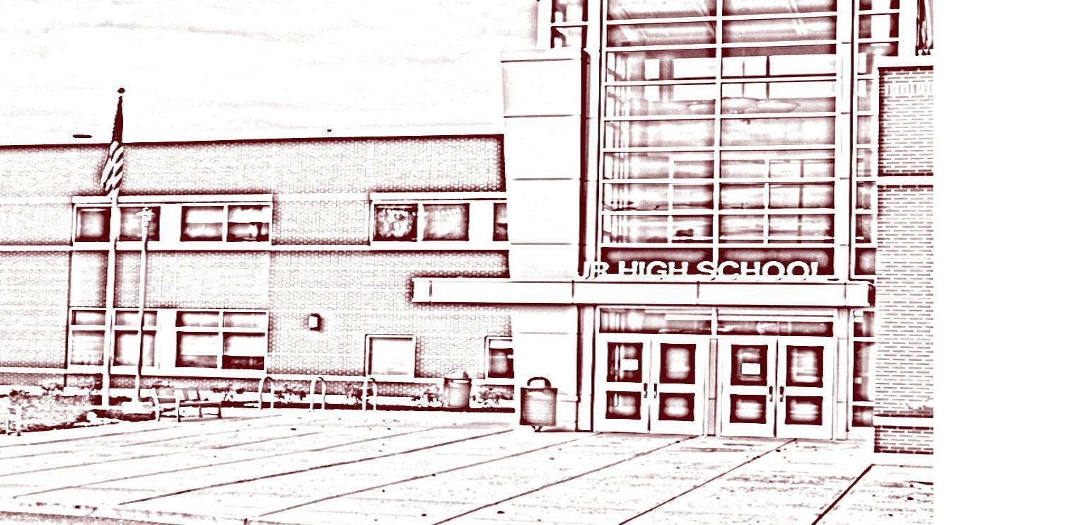

Hudson Junior High School
215 Harry Howard Avenue Phone (518) 828-4360
Hudson, NY 12534 Fax (518) 697-8522
__________________________________________________________________
Rhode Cooper Tyme Baez
Principal Associate Principal

November 13, 2022
Dear Families,

Parent Teacher Conferences will be held on Thursday, Nov. 17 from 1 p.m. to 3 p.m. and from 5 p.m. to 7 p.m. During the conference, you will be able to meet your child’s teachers and speak to them about their academic progress. Please note that our students will have an early dismissal on Thursday, Nov. 17th for parent teacher conferences. Below is the schedule.

2022-2023 Bell Schedule/Early Dismissal

Grade 6 | Grades 7 & 8
Period 1 8:05-8:27 | Period 1 8:05-8:27
Period 2 8:30-8:52 | Period 2 8:30-8:52
Period 3 8:55-9:17 | Period 3 8:55-9:17
Period 4 9:20 – 9:42 | Period 4 9:20 – 9:42
Period 5 9:45 – 10:07 | Period 5 9:45-10:07
Period 7 10:10 – 10:32 | Period 6 10:10-10:32
Period 8 10:35- 10:58 | Period 8 10:35-10:58
Period 9 11:02-11:25 | Period 9 11:02--11:25
Note: There will not be a lunch period during period 6 | Note: There will not be a lunch period during period 7
We believe that direct and personal communication with your child’s teachers is vital to his/her success. We encourage you to participate in these parent/teacher conferences. If for some reason you cannot attend, please be reminded that you are welcome to call the school throughout the school year. We look forward to seeing you at these conferences and wish everyone a wonderful Thanksgiving Holiday.
Sincerely Yours,
Rhode Cooper
Rhode Cooper

