



Edited: 9/29/2022

Cycle 3

French Toast Sticks

Sweet Potato Home Fries

Assorted Fruit

**NYS Milk**

**National French Toast Day!**

**Thanksgiving Break**

**Thanksgiving Break**

**Chefs Choice**

**Build Your Own:**

Mac & Cheese

*Toppings:* Buffalo Chicken, BBQ Chicken

Dinner Roll

Broccoli

Assorted Fruit

**NYS Milk**

Sausage, Egg & Cheese Sandwich

Home Fries

Assorted Fruit

**NYS Milk**

Cheese Pizza

Green Beans

Assorted Fruit

**NYS Milk**

**Half Day**

**No Lunch**

Turkey w/ Gravy

Mashed Potatoes

Corn

Dinner Roll

Assorted Fruit

**NYS Milk**

Sweet & Sour Chicken

Brown Rice/Egg Roll

Steamed Broccoli

Assorted Fruit

**NYS Milk**

**No School**

**Veterans Day**

Honey Sriracha Chicken

Brown Rice

Carrots

Assorted Fruit

**NYS Milk**

Pancakes

Turkey Sausage

Home Fries

Assorted Fruit

**NYS Milk**

Cheese Pizza

Roasted Broccoli

Assorted Fruit

**NYS Milk**

**NOVEMBER 2022**

High School Lunch Menu

Chicken Tacos

(cheese, salsa)

Cheesy Bean Dip

Fresh Veggies

Assorted Fruit

**NYS Milk**

Chicken Tenders

Garlic Breadstick

Sweet Potato Wedges

Assorted Fruit

**NYS Milk**

Beef Chili with Beans

Toppings: Sour Cream, Cheese,

Salsa

Corn Muffin

Assorted Fruit

**NYS Milk**

Roasted Chicken

Mashed Potatoes

Dinner Roll

Assorted Fruit

**NYS Milk**

Loaded Nacho’s

(taco meat, nacho cheese, salsa, sour cream)

Black Beans & Corn

Assorted Fruit

**NYS Milk**

Waffles

Turkey Sausage

Sweet Potato Home Fries

Assorted Fruit

**NYS Milk**

Jamaican Beef Patty

Sweet Potato Fries

Assorted Fruit

**NYS Milk**

Cheeseburger

Tator Tots

Assorted Fruit

**NYS Milk**

**Breakfast Choices:**

**Mondays- Cinni Mini**

**Tuesdays-Sausage, Egg & Cheese Sandwich**

**Wednesdays- Whole Grain Muffin**

**Thursdays-Waffle, Pancake or French Toast-Pending what is available**

**Fridays- W.G Donuts**

**Everyday Morning Choice of:**

Bagel with Cream Cheese

Assorted Cereal

Whole Grain Muffin

Graham Crackers

Fruit: 100% Fruit Juice and Fruit of the Day

Choice of Milk

**Alternate Lunch Options:**

Hummus with Pita Chips & Vegetables (served with fruit, choice of milk)

Yogurt (served with a grain, choice of fruit/veg, choice of milk)

Sandwich of the Day (served with fruit/veg, choice of milk)

**Sandwich of the Day:**

**Monday:** Turkey & Cheese Sandwich

**Tuesday:** Ham & Cheese Sandwich

**Wednesday:** Grilled Cheese

**Thursday:** Ham & Cheese Sandwich

**Friday:** Turkey & Cheese Sandwich

**Sun butter & jelly sandwich available upon request**

**Turkey products used for sandwiches**

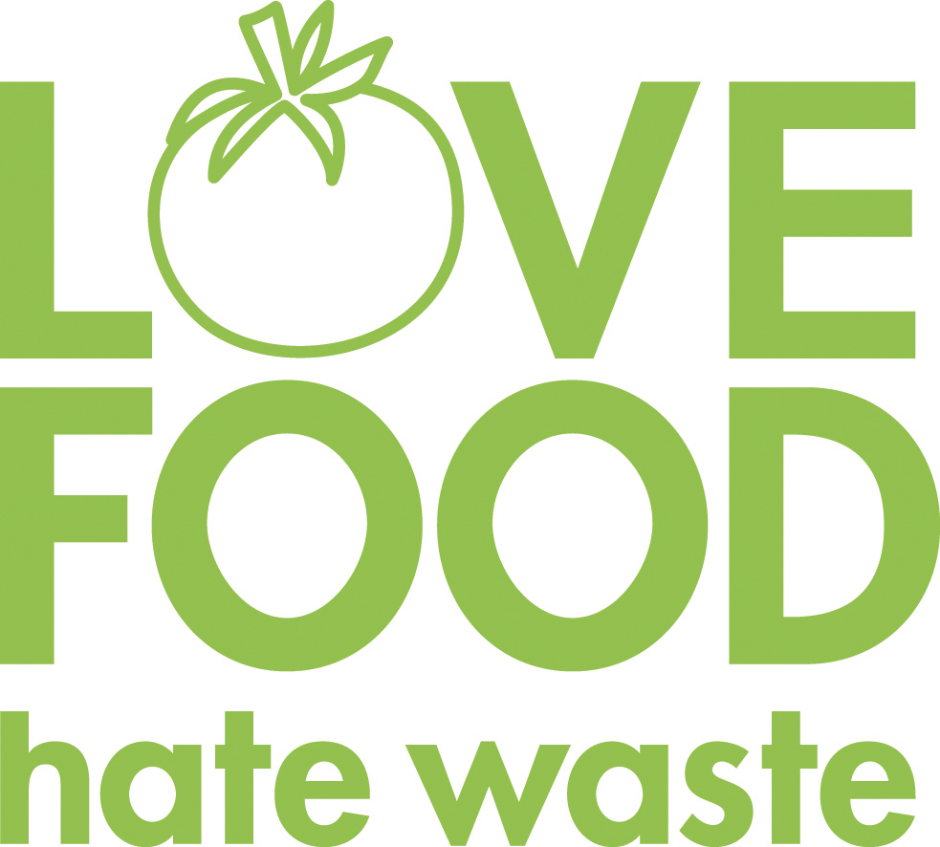

**Our food service department wants to prevent food waste! If there are any items in your school lunch that are prepackaged, remember to pack them up and save them for later. Cheese sticks, apples, Craisins, or fruit cups would be great for an afternoon snack!**

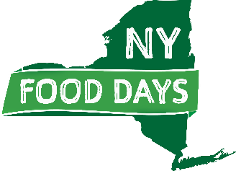

**We are striving to support our New York State food producers. Items highlighted in green are NYS food products.**

**Menus are pork free**

**Menu is subject to change, notice posted when available. The institution is an equal opportunity provider**

**NOVEMBER 2022**

Breakfast & Alternate Lunch Options