



Chicken & Waffles

Maple Syrup

Sweet Potato Home Fries

Assorted Fruit

**NYS Milk**

Cheeseburger

Flamin’ Hot Tater Tots

Assorted Fruit

**NYS Milk**

Edited: 9/29/2022

Cycle 3

French Toast Sticks

Maple Syrup

Sweet Potato Home Fries

Assorted Fruit

**NYS Milk**

**National French Toast Day!**

**Thanksgiving Break**

**Thanksgiving Break**

Cheese Pizza

Garden Salad

Assorted Fruit

**NYS Milk**

Loaded Quesadilla

(taco meat, cheese, peppers & onions)

Salsa & Sour Cream

Taco Fiesta Beans

Assorted Fruit

**NYS Milk**

Pancakes

Maple Syrup

Turkey Sausage

Home Fries

Assorted Fruit

**NYS Milk**

Cheese Pizza

Cucumbers & Hummus Dip

Assorted Fruit

**NYS Milk**

½ Day

Chicken Tenders

Garlic Breadstick

French Fries

Assorted Fruit

**NYS Milk**

Sweet and Sour Chicken

Brown Rice

Steamed Broccoli

Assorted Fruit

**NYS Milk**

**No School**

**Veterans Day**

Popcorn Chicken Bowl

Gravy & Mashed Potatoes

Corn

Assorted Fruit

**NYS Milk**

Crispy Chicken Sandwich

French Fries

Assorted Fruit

**NYS Milk**

Loaded Soft Tacos

(taco meat, cheese, lettuce, salsa, sour cream)

Black Beans & Corn

Assorted Fruit

**NYS Milk**

French Toast Sticks

Maple Syrup

Sweet Potato Home Fries

Pumpkin Pie Yogurt Parfait

Assorted Fruit

**NYS Milk**

**NOVEMBER 2022**

Elementary & Middle School Menus

Hot Dog on WG Bun

Vegetarian Bean

Assorted Fruit

**NYS Milk**

Chicken Tenders

Garlic Breadstick

Sweet Potato Wedges

Assorted Fruit

**NYS Milk**

Beef Chili with Beans

Toppings: Sour Cream, Cheese

Salsa & Chips

Corn

Assorted Fruit

**NYS Milk**

Crispy Chicken Sandwich

French Fries

Assorted Fruit

**NYS Milk**

Cheese Pizza

Broccoli

Assorted Fruit

**NYS Milk**

**Breakfast Choices:**

Served with: 100% fruit juice, fruit of the day, and choice of milk

**Alternate Lunch Options:**

Served with: fruit, vegetable, choice of milk

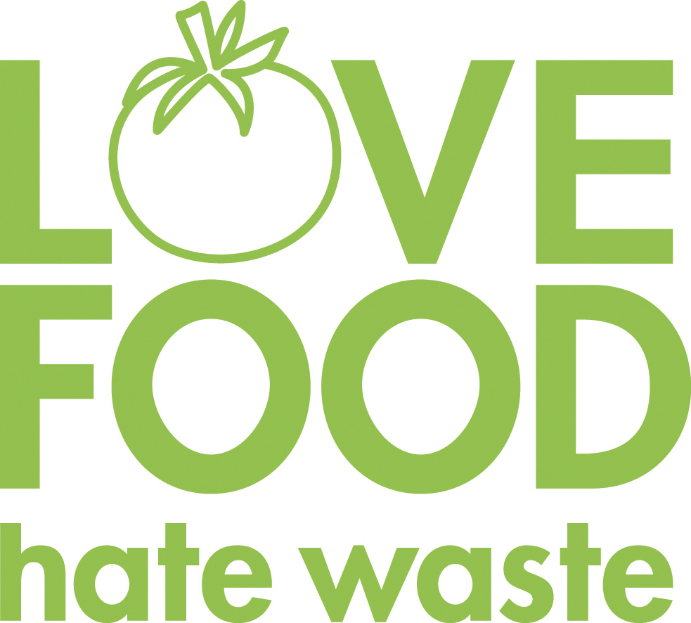

**Our food service department wants to prevent food waste! If there are any items in your school lunch that are prepackaged, remember to pack them up and save them for later. Cheese sticks, apples, Craisins, or fruit cups would be great for an afternoon snack!**

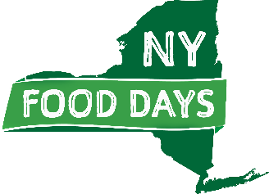

**We are striving to support our New York State food producers. Items highlighted in green are NYS food products.**

**Menus are pork free**

**Menu is subject to change, notice posted when available. The institution is an equal opportunity provider**

**NOVEMBER 2022**

Breakfast & Alternate Lunch Options