



Apple Strudel

Assorted Fruit Juice

Assorted Fruit

**NYS Milk**

Scrambled Eggs w/ Sausage

W.G Dinner Roll

Assorted Fruit Juice

Assorted Fruit

**NYS Milk**

Edited: 9/29/2022

Cycle 3

Cereal w/ Milk

Assorted Fruit Juice

Assorted Fruit

**NYS Milk**

**Thanksgiving Break**

**Thanksgiving Break**

Donuts

Assorted Fruit Juice

Assorted Fruit

**NYS Milk**

Cereal Bar

Assorted Fruit Juice

Assorted Fruit

**NYS Milk**

Oatmeal Apple Cinnamon

Round

Assorted Fruit Juice

Assorted Fruit

**NYS Milk**

Cereal Bar

Assorted Fruit Juice

Assorted Fruit

**NYS Milk**

Scrambled Eggs w/ Hash Brown

W.G Dinner Roll

Assorted Fruit Juice

Assorted Fruit

**NYS Milk**

Bagel & Cream Cheese

Assorted Fruit Juice

Assorted Fruit

**NYS Milk**

Mini Pancake

Assorted Fruit Juice

Assorted Fruit

**NYS Milk**

**No School**

**Veterans Day**

French Toast

Assorted Fruit Juice

Assorted Fruit

**NYS Milk**

Cereal Bar

Assorted Fruit Juice

Assorted Fruit

**NYS Milk**

Omelet w Cheese

W.G Roll

Sausage

Assorted Fruit Juice

Assorted Fruit

**NYS Milk**

Cereal w/ Milk

Assorted Fruit Juice

Assorted Fruit

**NYS Milk**

**NOVEMBER 2022**

Elementary Breakfast Menu

Mini Waffles

Assorted Fruit Juice

Assorted Fruit

**NYS Milk**

Cinn Bagel & Cream Cheese

Assorted Fruit Juice

Assorted Fruit

**NYS Milk**

Cinni Mini

Assorted Fruit Juice

Assorted Fruit

**NYS Milk**

Omelet w Cheese

W.G Roll

Sausage

Assorted Fruit Juice

Assorted Fruit

**NYS Milk**

Muffins

Assorted Fruit Juice

Assorted Fruit

**NYS Milk**

**Breakfast Choices:**

Served with: 100% fruit juice, fruit of the day, and choice of milk

**Alternate Lunch Options:**

Served with: fruit, vegetable, choice of milk

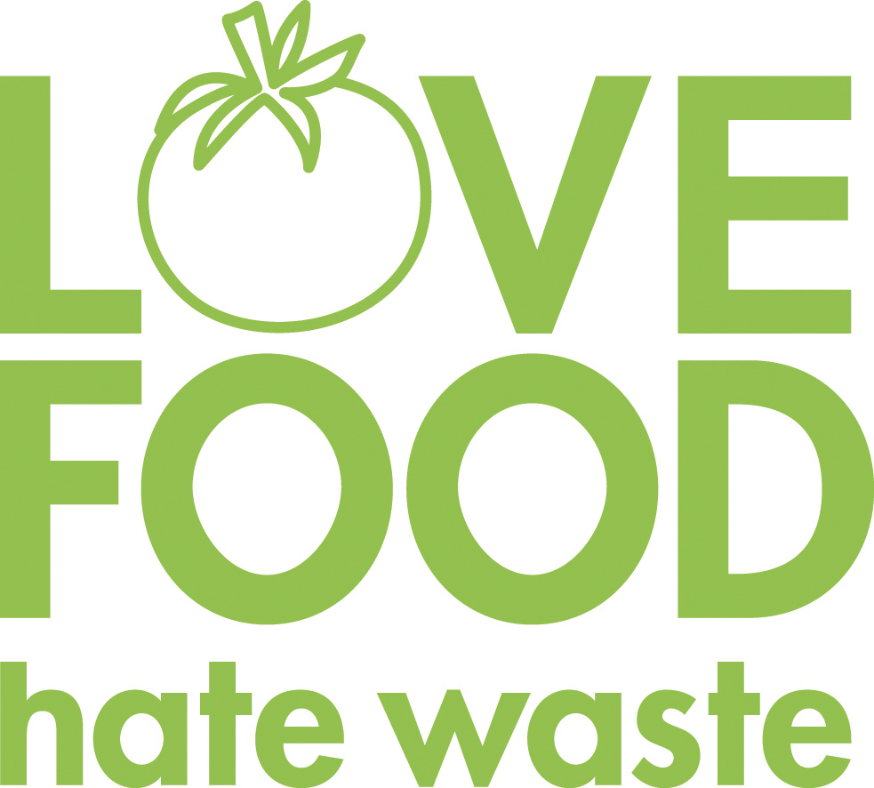

**Our food service department wants to prevent food waste! If there are any items in your school lunch that are prepackaged, remember to pack them up and save them for later. Cheese sticks, apples, Craisins, or fruit cups would be great for an afternoon snack!**

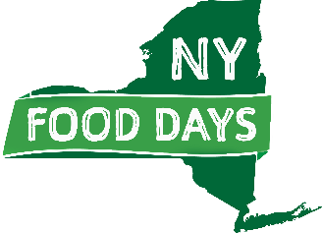

**We are striving to support our New York State food producers. Items highlighted in green are NYS food products.**

**Menus are pork free**

**Menu is subject to change, notice posted when available. The institution is an equal opportunity provider**

**NOVEMBER 2022**

Breakfast & Alternate Lunch Options